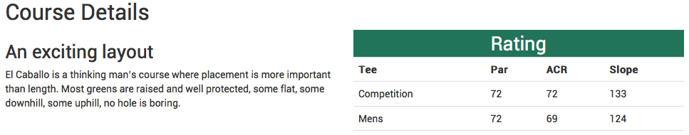
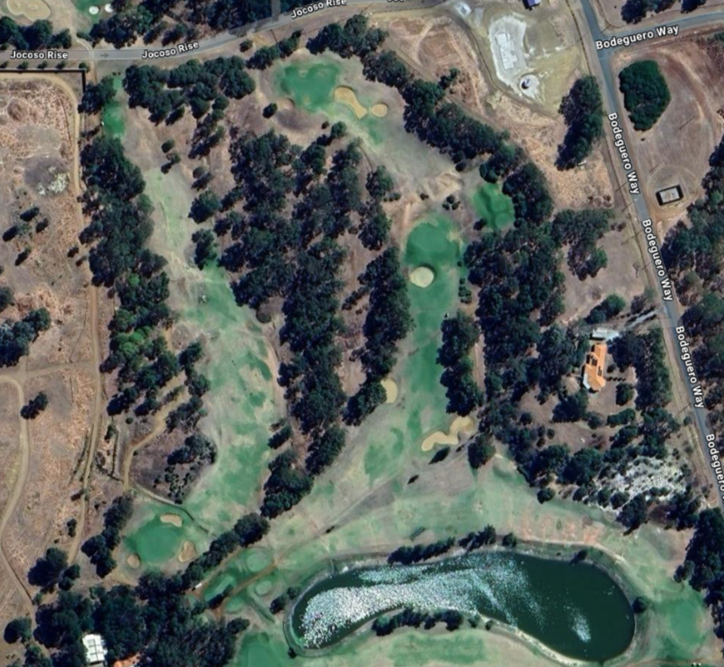
2 Par 3
1 Par 4

Hole 1 Par 4 (318 metres) Index 12 An uphill fairway and a raised green makes this hole play longer than it looks on paper. A long tee shot on the right may see you run out of fairway, a tee shot cutting the dogleg left corner missing the bunker is the best shot here. Green is sloped to the front right, and is guarded by a large bunker at the front. Best to hit a short iron in if possible.

Hole 2 Par 3 (161 Metres) Index 9 Once again a tee shot uphill to a green protected by a large bunker at the front, take plenty of club as mounds at the back right of the green will stop you going too long. A long shot to the left may find a hidden bunker at the left rear.
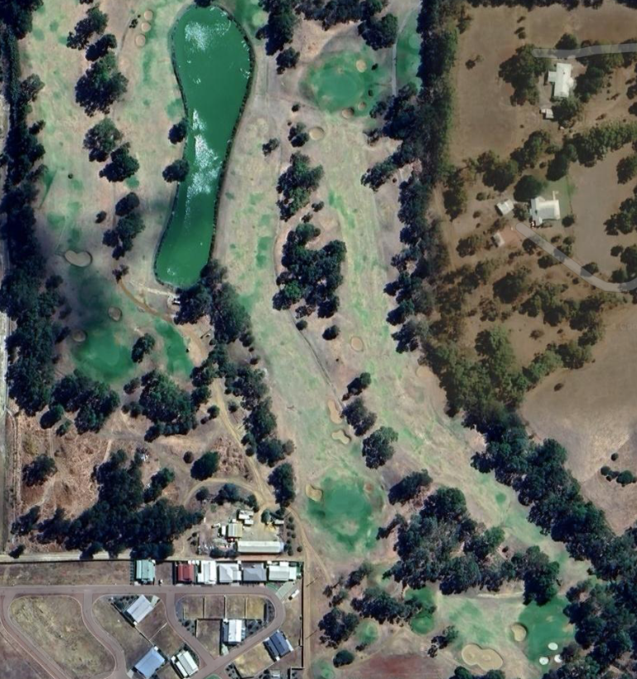
8 Par 3
7 Par 4
6 Par 4
3 Par 5
Hole 3 and some return holes 6, 7 & 8

Hole 3 Par 5 (448 Metres) Index 13 A dogleg right , if you want to be on in 2 you need a long tee shot cutting close to the corner, a raised fairway makes it hard get on with a long iron. The green is wide but shallow, hard to stay on the left side but mounds from the bunkers back and front on the right side make for a better landing.

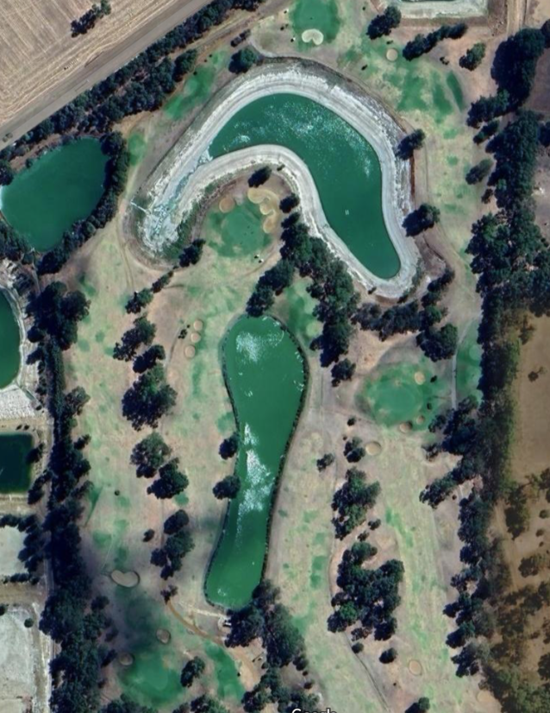
4 Par 4
7 Par 4
6 Par 4
5 Par 5

Hole 4 par 4 (318 Metres) Index 15 A short hole with a dogleg left, tee shot is the key here, you may be tempted to go for the green and is reachable but there is out of bounds over the back and carrying the water gets difficult if you stray left. A straight iron shot down the centre is a better way to go as the green is not hard to hit from most places on the fairway.

Hole 5 par 5 (444 Metres) Index 12 The best chance for a birdie, a long tee shot keeping to the left should bring you well within range. A slightly raised large green is protected at the front left and right by bunkers, the green has some subtle roles.

Hole 6 par 4 325 metres, (index 10)
Water on the right makes this short hole harder than it looks, the fairway tightens up if you go too long, fairway bunkers on the left catch a long ball. A long iron is the best here, you want to be close without catching the bunkers to give you a good chance of making birdie. With a small lip at the front and bunkers all around the back of the green a short iron is preferable.

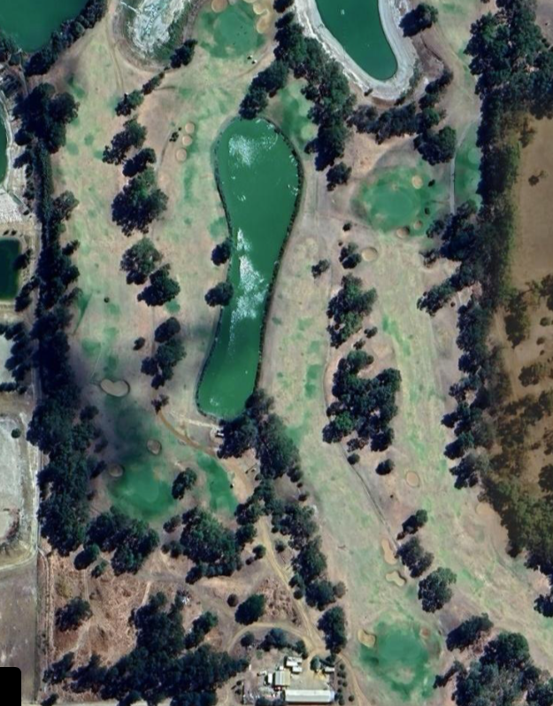
7 Par 4
6 Par 4

Hole 7 par 4 392 metres (index 2)
A long hole at just under 400 meters, an uphill fairway and a high raised green this hole plays a lot longer. A long tee shot keeping to the left to avoid water and hazards on right is needed, take plenty of club for your second shot as a short shot could see you roll all the way back down the slope. The green is protected by bunkers on the left and right, with slight mounds at the back help you with a long shot in.

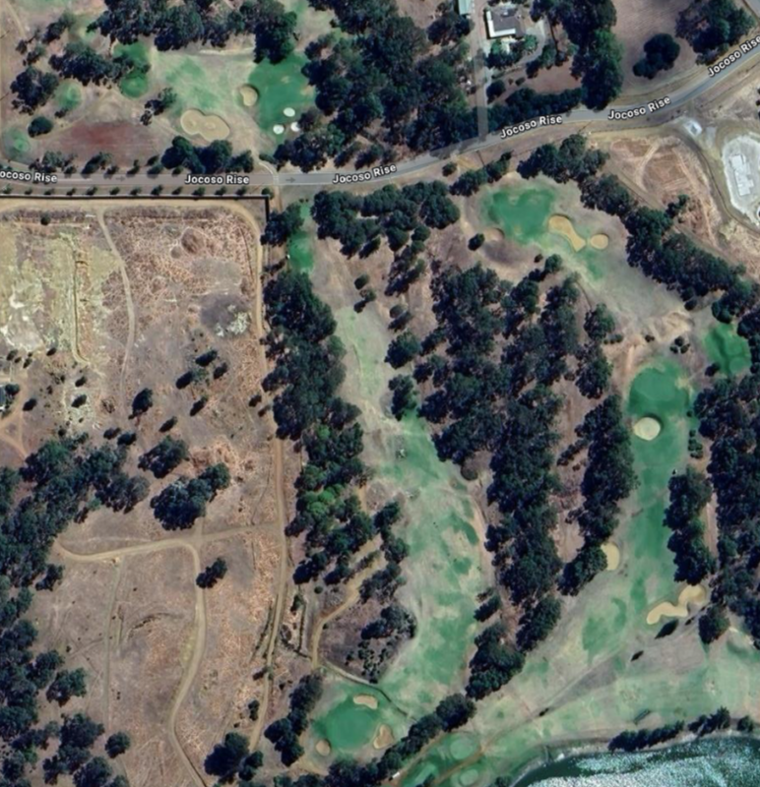
8 Par 3
2 Par 3
1 Par 4
9 Par 4
Hole 8 par 3 165 metres index 8
With a drop-off the back, bunkers at the front and right this green is well protected, the exception being the left where the grass slops towards the green. From the blue tees this is a quite easy hole. From the back tees the shot is quite daunting but rewarding for brave hitters.

Hole 9 par 4 346 metres index 10
A downhill dogleg right, a long tee shot becomes tight and is not necessary, a slightly shorter tee shot gives you a wide landing area and a second shot over the trees down to a large green is not too difficult. The green slopes to the left and bunkers on the left, front and rear mean you should error to the right. A sloping green means putting can be tricky.

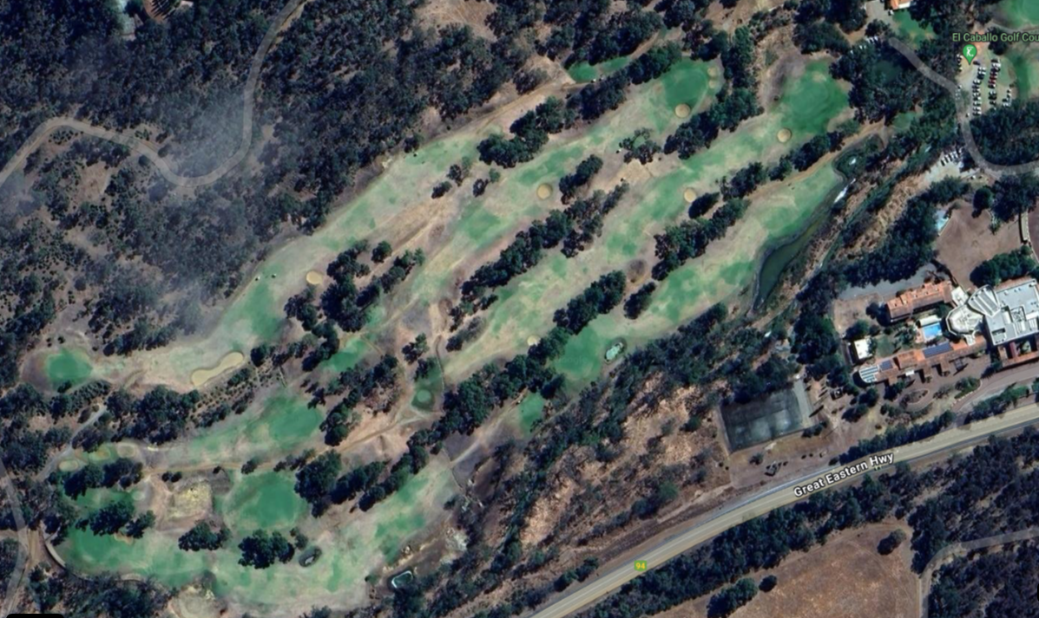
15 Par 3
12 Par 3
11 Par 4
16 Par 5
14 Par 5
13 Par 4
10 Par 4

Hole 10 par 4 304 metres index 11
A short par 4, reachable in two but a high risk shot, the green is guarded by ponds on the back, and left front, and hazards and trees on the right front, laying up here is the way to go. Water on the left comes into play if tee shot is mishit. The green is raised and hard to stay on. A wedge over the trees to the right hand side is the safer shot.

Hole 11 par 4 348 metres index 3
A dogleg right, with a small pond on the corner and water to catch the long drive makes this hole tricky. Hitting long to the left you will run out of fairway, cutting the corner means hitting a narrow piece of fairway to avoid water. Best shot is to carry the small pond on the corner then pull up quick. Green is sloped to the left with out of bounds on left and rear. Tricky putting makes this a danger hole.

Hole 12 par 3 139 metres index 18
A short par 3 at index 18 is the easiest on the course, but a steeply raised green at the front and right means a slice or a short shot can means disaster. Take plenty of club, green is large and relatively flat.

NOTE
You need to cut across to hole 13

Hole 13 par 4 306 metres index 5
A short but tricky par 4. Keep your tee shot to the left and you will roll back to the centre of the fairway, look out for fairway bunker well placed on the right. A two tiered green slopes to the right where a bunker catches many approach shots and even some wayward puts. Putting is never easy.

15 Par 3
14 Par 5
12 Par 3
16 Par 5
13 Par 4
11 Par 4
10 Par 4

Hole 14 par 5 499 metres index 1
At index 1, this par 5 is the hardest on the course, it requires 3 well placed shots. A long tee shot seldom works out well, an iron to the top of the hill is the best tactic here. The fairway gets tighter the longer you try to place your second shot, but laying up too short means a hard third into the green. The green is hard to stay on, with steep drops on left and back into the abyss. A well thought out hole that experienced golfers will appreciate.

Hole 15 par 3 161 metres index 17
Try to hit to the back center of the green if you want to stay on, chipping on from sides could see you going all the way over, putting is rarely straight. This hole is harder than its index would suggest.

Hole 16 par 4 421 index 14
The shortest par 5 on the course, reachable in 2 for the average golfer, but fairway short of green slopes off to the right making rolling onto the green hard. The green is large sloping to the front, hit your second in on the full for the best chance.

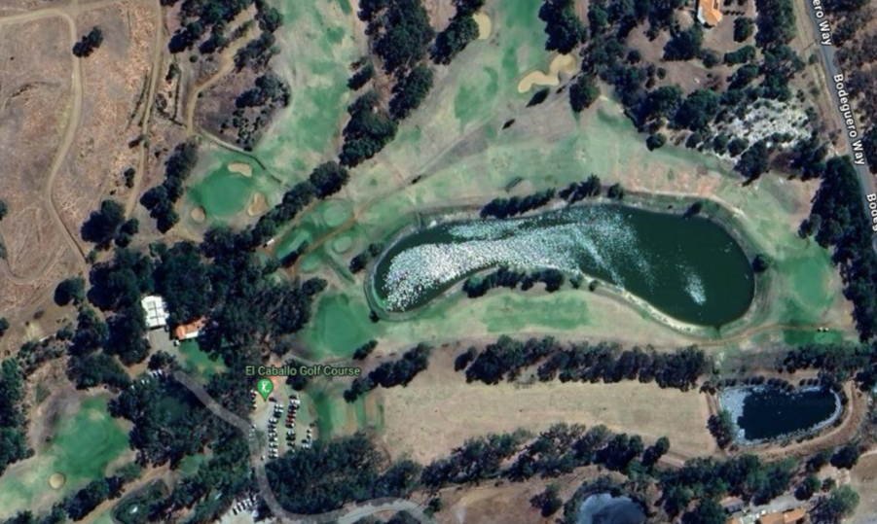
18 Par 4
17 Par 4

Hole 17 par 4 370 metre index 4
Doglegging right around a lake with out of bounds to the left rear of the green makes this hole hard. Fairway narrows for the long tee shot, keeping your tee shot safe but long enough to hit the green on your second is the key.

Hole 18 par 4 312 metres index 7
Water on the right, driving range on the left you need a straight tee shot. Past the distance signs on the driving range is out of bounds. Water will catch a short approach shot as well as water at the back of green for the long one. Green is easy putting but you need to hit it first. Left side of green is safest.

